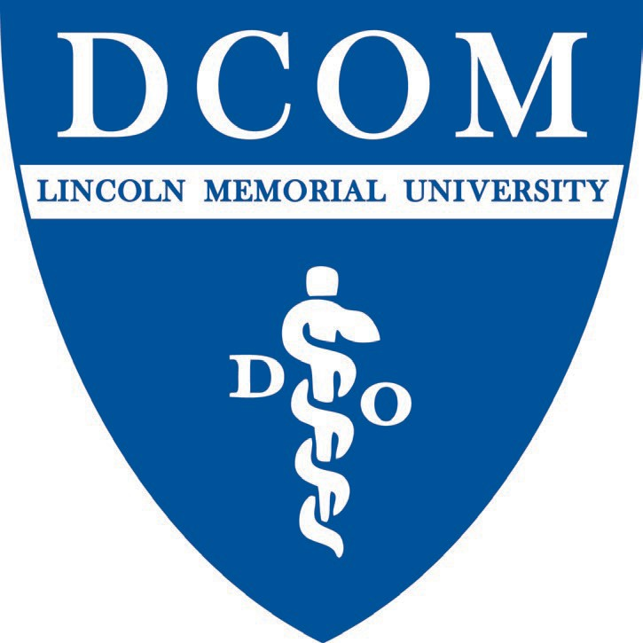2024-2025

LMU-DCOM

Student Club Application

Starting a New Club

* Organizations and societies
  + Student clubs can be classified as either organizations or societies. Regardless of whether a student club is classified as an organization or societies, all student clubs must maintain the same requirements and provide the same benefits and resources from the Student Services Department.
    - Student clubs that fall under "organizations" primarily focus on helping club members prepare for a residency track. All organizations must be nationally affiliated.
    - Student clubs that fall under "societies" primarily focus on creating a "sense of belonging" with students in LMU-DCOM. They seek ways to connect with others and focus on advocacy. Societies may be nationally affiliated.

Steps for starting a new club

* Submit a New Club Application
  + Students should complete the New Club Application that contains the following:
  + Obtain a membership roster with at least 10 interested individuals
  + List positional candidates for club office positions
  + Obtain faculty/staff advisor
  + [Draft a rough](https://www.dcomdo.com/club-forms) club Constitution and/or by-laws
  + Draft the Mission/Purpose of the club

Required positions to maintain active club status. All executive board members submitting club applications must be in good academic and professional standing.

* President
  + The president oversees club operations and presides over all club meetings.
  + One of the main organizers of club events.
  + Sometimes required to attend national conferences.
* Vice President
  + Assists the president in the oversight of club operations and club meetings.
  + Assist with the organization of club events.
  + Attends national conferences in the event the president cannot attend.
* Secretary
  + Schedules club meetings with Student Services.
  + Takes minutes at all club meetings.
    - Club Minutes Form can be found on your club’s Teams Account
* Treasurer
  + Keeps record of club expenses.
  + Responsible for maintaining an internal budget spreadsheet.
  + Responsible for submitting quarterly financial reports to Student Services.
  + Initial point of contact for club conference funding
  + Will vote with the executive board on the exact conference funding allotment for students.
* National Reps (if applicable)
  + Travel to national conferences on behalf of the club.
  + Follow student travel guidelines.
  + Give reports of conference experience to the respective club during the next scheduled club meeting.
  + Other positions may be held in clubs, but any new positions must be implemented into club bylaws.

Faculty/Staff Advisors

* Every club is required to have 1 faculty/staff advisor who is employed at LMU-DCOM.
  + Advisors are encouraged to have some affiliation or interest in the clubs they are representing.
  + Faculty/staff advisors must be agreed upon annually by a majority vote of the club e-board.
  + It is the club leaders’ responsibility to keep faculty/staff advisors informed regarding club events.
  + Faculty/staff advisors may step down from their role for any reason and it is the club’s responsibility to fill the role.
  + All faculty/staff advisors must participate in an annual training hosted by Student Services.

Club Status

* To maintain active status, each club will fulfill the requirements below. Clubs will be periodically audited by Student Services. If a club is not meeting the requirements, they will be demoted from active status and will need to follow the steps outlined in “Starting a Club” to become active status again.
  + Meet minimum club requirements
    - Attendance at Osteoblast
    - End of Year (EOY) reports
      * Each club will submit EOY reports to the Student Services Department. Templates for these reports can be requested from student services. Reports will include a summary of fundraising efforts. Reports will include a financial report for the year in addition to the quarterly reports. Reports will include the number of meetings and the number of attendees at each meeting. Reports will include descriptions of events sponsored, if any.
  + Meeting requirements
    - Clubs will hold a minimum of two meetings each semester. Club secretaries will keep an attendance record at each meeting. This record will be used in the quarterly and EOY report.
  + Attendance at Osteoblast
    - Clubs will set up a table at Osteoblast each year. At least two e-board members of the club will be present at the table for the entire osteoblast event. Failure to attend Osteoblast is grounds for removal from active club status.
  + Fundraising and Community Service
    - Clubs will conduct at least one fundraiser and one community service event each academic year. Failure to conduct is grounds for removal from active club status.

## 2024-2024 LMU-DCOM Club Application Submission

|  |  |  |
| --- | --- | --- |
| INFORMATION |  | |
| Name of Club: |
| Campus:  *(Circle one option)*  Registration Status:  *(Circle one option)* | Harrogate  New Club | Knoxville  Reapplying Club |
| Type of Club:  *(Circle one option)* | Organization | Societies |
| Purpose of Organization:  Click or tap here to enter text. |  |  |

Is this organization affiliated with another local, state, or national organization?

Yes  No

*If yes, please specify which group:

Club Requirements

FUNDRAISING

* Each club is encouraged to perform 1 (one) approved fundraiser per academic year.
* Tentative Fundraiser idea:
  + In a separate document, please include your fundraising idea and reference the LMU- DCOM Club Manual for club fundraising specifics.

COMMUNITY SERVICE

* Each club is required to perform at least 1 (one) approved community service project per year. The service projects should be necessary and valuable to the community at large.
* Tentative Community Service Project:
  + In a separate document, Please include your community service idea in your presentation to SGA and reference the LMU-DCOM Club Manual for community service specifics.

MEETING MINUTES

* Each club is required to submit meeting minutes of (at least) 2 scheduled meetings that were performed during each semester of the academic year. Failure to do this will put clubs at risk of probation.

CLUB RELEASE INFORMATION

The following information may be included on the LMU-DCOM website and will be available to on and off-campus entities that request a list of student organizations, contact names, phone numbers, and email addresses unless otherwise indicated in this section. The completed form allows LMU-DCOM to release the information provided to interested students, faculty, staff, and administrators.

NATIONAL/INTERNATIONAL INFORMATION

If applicable, organizations must submit a copy of the national or international Constitution with this application.

* Name of International/National Organization:
* Address:
* Phone:

OFFICER INFORMATION

Club Name:

PRESIDENT

Name:

Email:

VICE-PRESIDENT

Name:

Email:

SECRETARY

Name:

Email:

TREASURER

Name:

Email:

OTHER

Please list additional officers (*if applicable*):

PRESIDENT RESPONSIBILITY STATEMENT

I hereby verify the following information:

* Activities to be engaged in by this club adhere to the rules and regulations of LMU-DCOM and the University.
* Activities to be engaged in by this organization are compatible with the educational goals of LMU-DCOM.
* I have reviewed the current *LMU-DCOM Student Club Manual,* and I fully understand that it is my responsibility to guide and educate the members of my organization in correlation with these policies.

President Name:

Print Signature:

Date:

ADVISOR(S) CONFIRMATION

LMU-DCOM requires all registered student clubs to have an advisor. This must be a

member of the LMU-DCOM faculty, staff, or administration and is responsible for the following:

* Attendance of at least 1 (one) meeting per semester with the club officers.
* To carry out the duties assigned to the advisor by the club’s approved Constitution/Bylaws.
* To serve as a liaison between LMU-DCOM and the respective student club.
* To interpret and advise the club’s policies and procedures.
* To be aware of and assist the club in the management of its financial operations.
* To ensure compliance with all State and University financial procedures.
* To assist the organization in planning/executing its programs and events.

I agree to serve as the advisor(s) to the above-mentioned student organization for the 2022- 2023 academic year, including having my name and email address on the respective student club webpage and intend to fulfill the above responsibilities to the best of my ability.

Advisor (1)

Print Name:

Signature:

Email:

Date:

*\*\*IF APPLICABLE: Advisor (2)*

*Print Name:*

*Signature:*

*Email:*

*Date:*

STUDENT CLUB OFFICER HONOR AGREEMENT

We, the officers, hereby state that we have read and understand the contents of the *LMU- DCOM Club Manual*. Any information contained within this document is superseded by the *LMU- DCOM Student Handbook* and Lincoln Memorial University Policies and Procedures.

We acknowledge that the officers of *(insert club name)* have read and understand the policies and procedures contained within the *LMU-DCOM Club Manual*.

PRESIDENT:

PRINT NAME

SIGNATURE

VICE PRESIDENT:

PRINT NAME

SIGNATURE

SECRETARY:

PRINT NAME

SIGNATURE

TREASURER:

PRINT NAME

SIGNATURE

OTHER OFFICER:

PRINT NAME

SIGNATURE

OTHER OFFICER:

PRINT NAME

SIGNATURE

Please submit a new club application to Keaton Grimmett ([Keaton.grimmett@lmunet.edu](mailto:Keaton.grimmett@lmunet.edu)) for DCOM-Harrogate and Stephanie Mullins ([stephanie.mullins@lmunet.edu](mailto:stephanie.mullins@lmunet.edu)) for DCOM-Knoxville